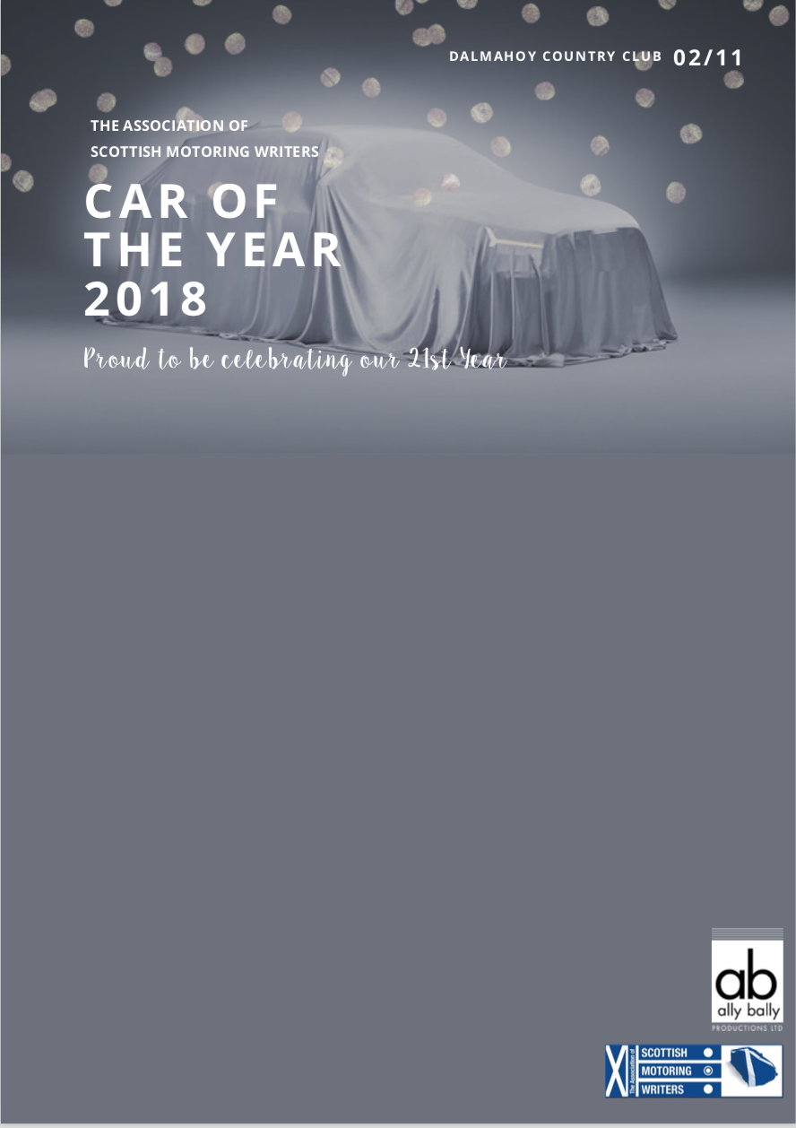

RESERVE YOUR SCOTY TICKETS & ROOMS
TABLES
Table of 10: £1300 or individual tickets: £130

ROOMS
Rooms are £120 single occupancy or £130 for double

Name of company:
Invoice name:
Name of contact:
PO (if applicable):

Reserve X tickets at £130 per person
Reserve X tables at £1300 per table

Reserve X single rooms at £120
Reserve X double rooms at £130

Please type yes if you would like pay by card and we will contact you to arrange payment:

